PL SQL TASK

1.Create Database

create database aspire_nov_batch;

use aspire_nov_batch;

2.Create Table

Create TABLE products(

productId int(4) not null,

productName varchar(20) not null,

qty int(5) not null,

price int(7) not null

);

3.Insert Values

insert into products values

(101,'soap',10,50),

(102,'paste',20,35),

(103,'clip',200,15),

(104,'bucket',5,250),

(105,'mug',5,40),

(106,'detergent',75,10),

(107,'brush',80,25),

(108,'waterbottle',60,50),

(109,'thumbler',300,5),

(110,'cleaner',20,75);

4.View Table contents

select * from products;

5. Case Statement

select productId, productName, price,

case

when price >=100 then 'Expensive'

when price <100 and price >50 then 'Affortable'

when price <=50 then 'Cheap'

else 'product price not match'

end as catagory

from products;

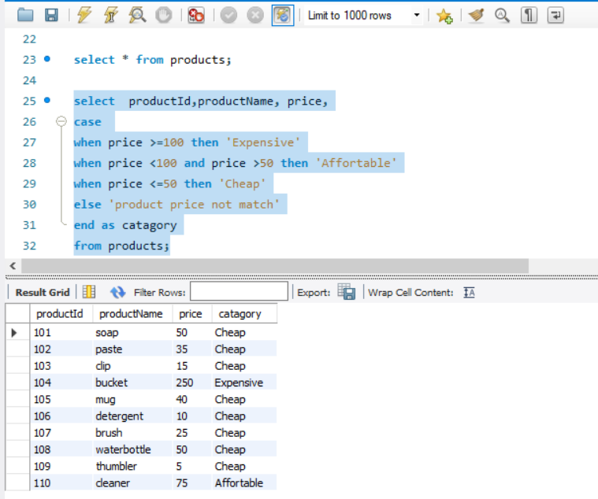

6.Create Procedure – takes a product id as input parameter and returns the details of that product

DELIMITER //

create procedure getDetails (in id int)

begin

select * from products where productId = id;

end //

7.Excecute Procedure

CALL getDetails(105);

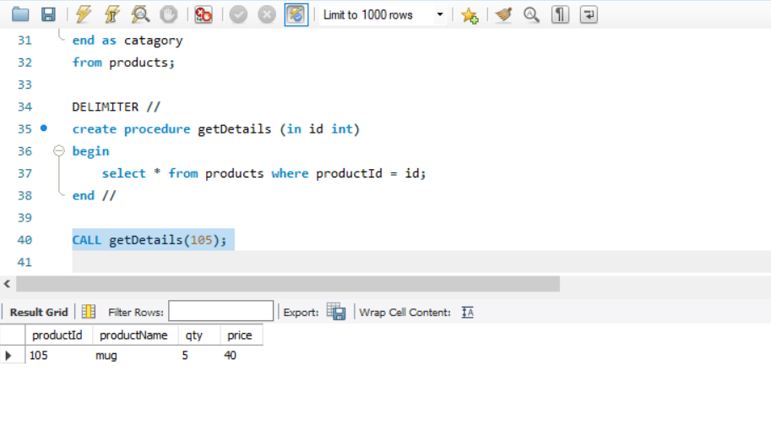

8.Create Function - takes price as argument and returns the details of products whose price is greater than argument

DELIMITER //

create function GetProduct (aboveprice numeric)

returns varchar(500)

deterministic

begin

declare pname varchar(500);

SELECT group_concat(productName separator ', ') into pname from products where price > aboveprice ;

return pname;

End//

9.Call function

select GetProduct(20);

